Domain Modelling & Application Architecture
Current Plant domain model, DAO abstraction, JavaFX separation, persistence architecture and implementation evolution
Evolution: Week 7 architecture proposal -> Week 9 implemented package and persistence structure

1. Architecture Objective
Plantopedia separates the plant domain model and data-access responsibilities from JavaFX presentation code. The architecture has evolved from an early conceptual structure into an implementation that includes a Plant domain object, IPlantDAO abstraction, MockPlantDAO, SQLitePlantDAO and a central DatabaseConnection.

2. Current Core Domain Model
Element | Responsibility | Current status
Plant | Represents one plant record and its implemented descriptive, distribution and taxonomic fields. | Implemented
IPlantDAO | Defines the contract used to add, update, delete, retrieve and query Plant objects. | Implemented
MockPlantDAO | Provides a non-persistent/in-memory DAO implementation useful for development and decoupling. | Implemented
SQLitePlantDAO | Persists Plant objects using JDBC and the PlantsData table. | Implemented
DatabaseConnection | Centralises the SQLite JDBC connection and supports test redirection. | Implemented
JavaFX pages/components | Present and collect information without directly embedding persistence SQL. | Implemented / ongoing integration
User/authentication classes | Provide user/account functionality developed elsewhere in the team codebase. | Team implementation / integration

3. Implemented Plant Domain Fields
Java field | Domain meaning
id | Unique plant identifier.
generalisedInfo | General descriptive information.
images | Image reference/data.
stateProvince | Geographic occurrence.
scientificName | Scientific/botanical name.
kingdom | Taxonomic kingdom.
phylum | Taxonomic phylum.
pclass | Taxonomic class; named pclass in Java to avoid the class keyword.
order | Taxonomic order.
family | Taxonomic family.
genus | Taxonomic genus.
taxonRank | Taxonomic rank.
vernacularName | Common/vernacular name.
species | Species information.

4. DAO Abstraction
The DAO pattern separates domain/application behaviour from the storage mechanism. Both MockPlantDAO and SQLitePlantDAO implement the same IPlantDAO contract. The application can therefore use plant operations without needing to know whether records are held in memory or in SQLite.
IPlantDAO
/ \
/ \
MockPlantDAO SQLitePlantDAO
| |
in-memory data JDBC
|
PlantsDB.db
|
PlantsData

5. Layered Application Architecture
JavaFX Presentation Layer
Pages / reusable components / navigation
↓
Application & Domain Behaviour
Plant objects + user interaction logic
↓
Data Access Abstraction
IPlantDAO
↙ ↘
MockPlantDAO SQLitePlantDAO
↓
Persistence Infrastructure
DatabaseConnection -> SQLite JDBC -> PlantsDB.db
The important architectural rule is that SQL belongs in the persistence/data-access implementation rather than inside JavaFX page classes. This improves maintainability and allows the data-access implementation to be tested independently of the graphical user interface.

6. Current Package Structure
The structure below reflects the current project direction observed during the Week 9 integration. It replaces the earlier hypothetical service/controller/database-manager skeleton with the classes actually present or being integrated.
src/main/java/
├── app/
│ ├── model/
│ │ ├── Plant.java
│ │ ├── IPlantDAO.java
│ │ ├── MockPlantDAO.java
│ │ └── SQLitePlantDAO.java
│ ├── components/
│ │ └── reusable JavaFX components
│ └── pages/
│ └── JavaFX application pages
├── database/
│ └── DatabaseConnection.java
└── User/
└── user/authentication classes
src/test/java/
├── PlantTest.java
├── SQLitePlantDAOTest.java
└── DatabaseConnectionTest.java

7. Responsibility Flow Examples

7.1 Retrieving plant information
JavaFX page requests plant data
↓
IPlantDAO operation
↓
SQLitePlantDAO
↓
DatabaseConnection
↓
PlantsData SELECT
↓
ResultSet mapped to Plant object
↓
Plant returned to application/UI

7.2 Adding or updating a plant
Plant object
↓
IPlantDAO.addPlant / updatePlant
↓
SQLitePlantDAO PreparedStatement
↓
INSERT / UPDATE PlantsData
↓
Persisted record

8. Testing Architecture
The architecture supports testing at more than one level. PlantTest verifies the domain object's state and accessors. SQLitePlantDAOTest verifies persistence behaviour against isolated temporary SQLite databases. DatabaseConnectionTest verifies that the connection layer can open the required database.
Test class | Primary responsibility | Layer
PlantTest | Plant object fields, getters/setters and edge/object-state behaviour. | Domain model
SQLitePlantDAOTest | CRUD, retrieval, search, pagination, field mapping and persistence edge cases. | Data access / persistence
DatabaseConnectionTest | SQLite connection behaviour. | Persistence infrastructure

9. Evolution from the Week 7 Architecture
Week 7 concept | Week 9 refinement
Plant model centred on commonName, habitat, growing and safety fields. | Plant model aligned with the integrated dataset: generalisedInfo, stateProvince and structured taxonomy.
PlantDAO / MockDAO / SQLite DAO ideas still being planned. | IPlantDAO, MockPlantDAO and SQLitePlantDAO now provide a concrete abstraction and persistent implementation.
DatabaseManager and DatabaseInitializer proposed. | DatabaseConnection is the implemented connection abstraction; test setup creates its own temporary schema.
Service/controller packages proposed as future separation. | Current JavaFX pages/components and DAO separation are documented as implemented; uncreated service/controller classes are not claimed.
Basic model tests proposed. | Domain and persistence tests now provide substantially broader automated coverage.

10. OOP and Software Engineering Principles Demonstrated
- Encapsulation: Plant stores state behind methods rather than exposing database rows directly.
- Abstraction: IPlantDAO defines what plant persistence must do without prescribing how it is stored.
- Polymorphism: MockPlantDAO and SQLitePlantDAO can satisfy the same DAO contract using different storage strategies.
- Separation of concerns: JavaFX presentation, domain model, data access and database connection have different responsibilities.
- Testability: SQLite persistence can be exercised using temporary databases without launching the JavaFX interface.
- Iterative design: the domain and database structures were refined as the team integrated the actual dataset and persistence requirements.

11. Current and Future Architecture
For the current prototype, the implemented structure is intentionally practical. Additional service classes, normalised distribution/source tables, favourites persistence or richer safety/growing value objects should only be introduced when corresponding user stories require them. This avoids unnecessary architecture while preserving a clear extension path.
CURRENT
JavaFX -> IPlantDAO -> SQLitePlantDAO -> SQLite
POSSIBLE FUTURE REFINEMENT
JavaFX -> Controller/Service -> IPlantDAO -> SQLitePlantDAO -> SQLite
├-> User/Favourite persistence
├-> PlantSource
└-> PlantDistribution / richer domain objects

12. Checkpoint Evidence
- Plant domain object aligned with the persisted dataset.
- DAO interface and two implementations demonstrate abstraction and substitution.
- SQLite JDBC persistence is separated from JavaFX presentation code.
- Automated domain and persistence tests provide evidence of implemented behaviour.
- Git history and pull request activity show the persistence work being developed on a feature branch and integrated with the evolving team codebase.
- The documentation distinguishes implemented functionality from deferred design ideas.

DAO abstraction

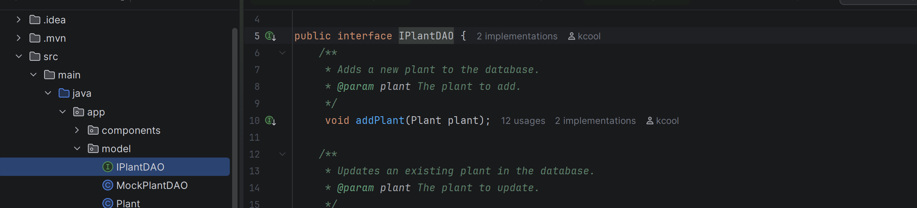

Actual JDBC persistence

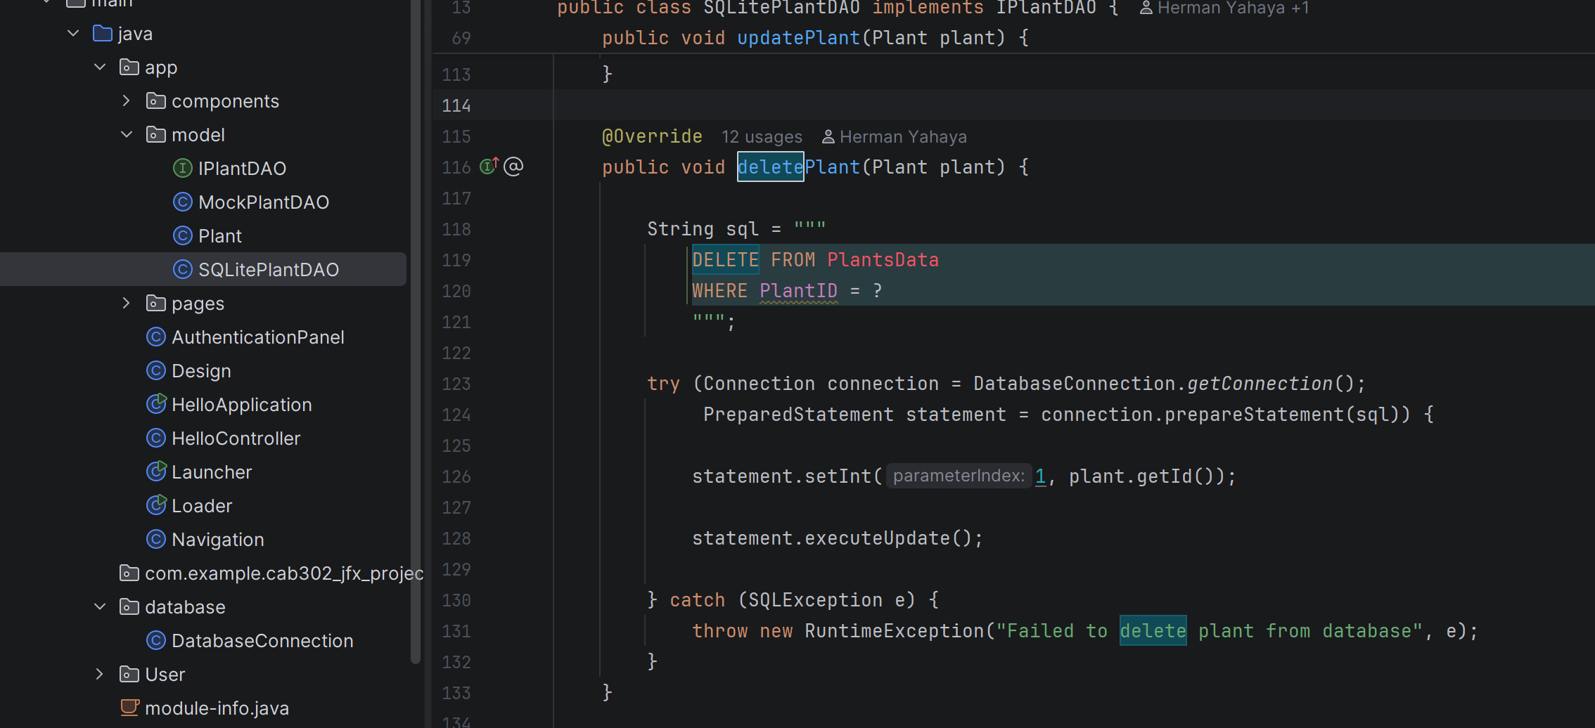

JUnit persistence verification

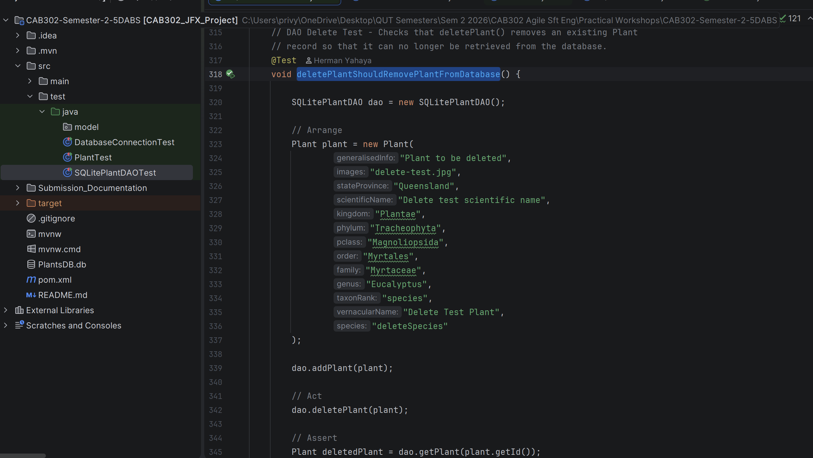

16 Tests Passed in SQLitePlant DAO
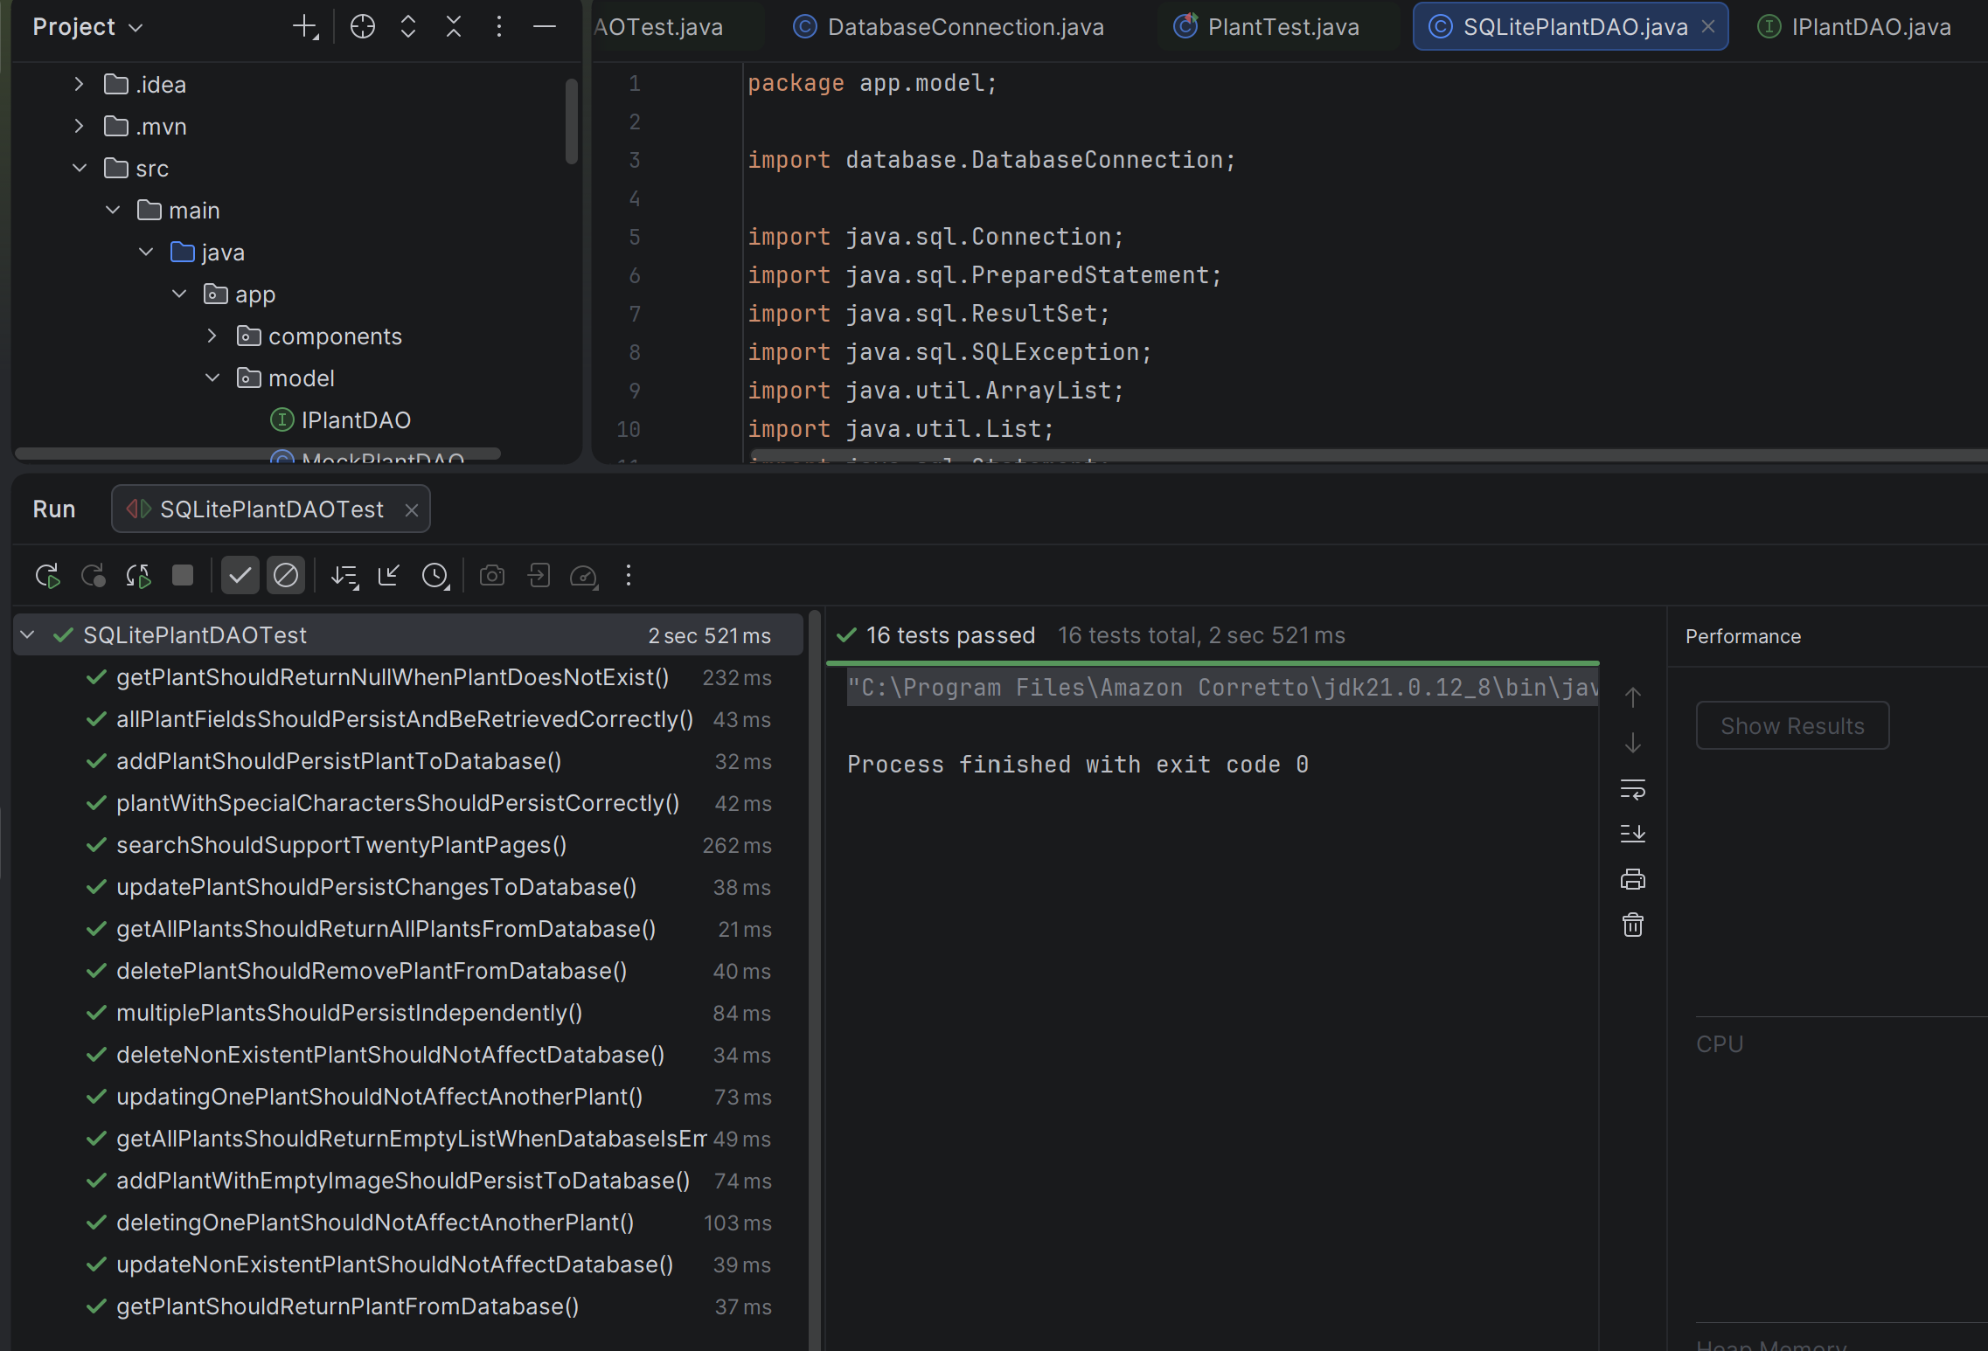assed in
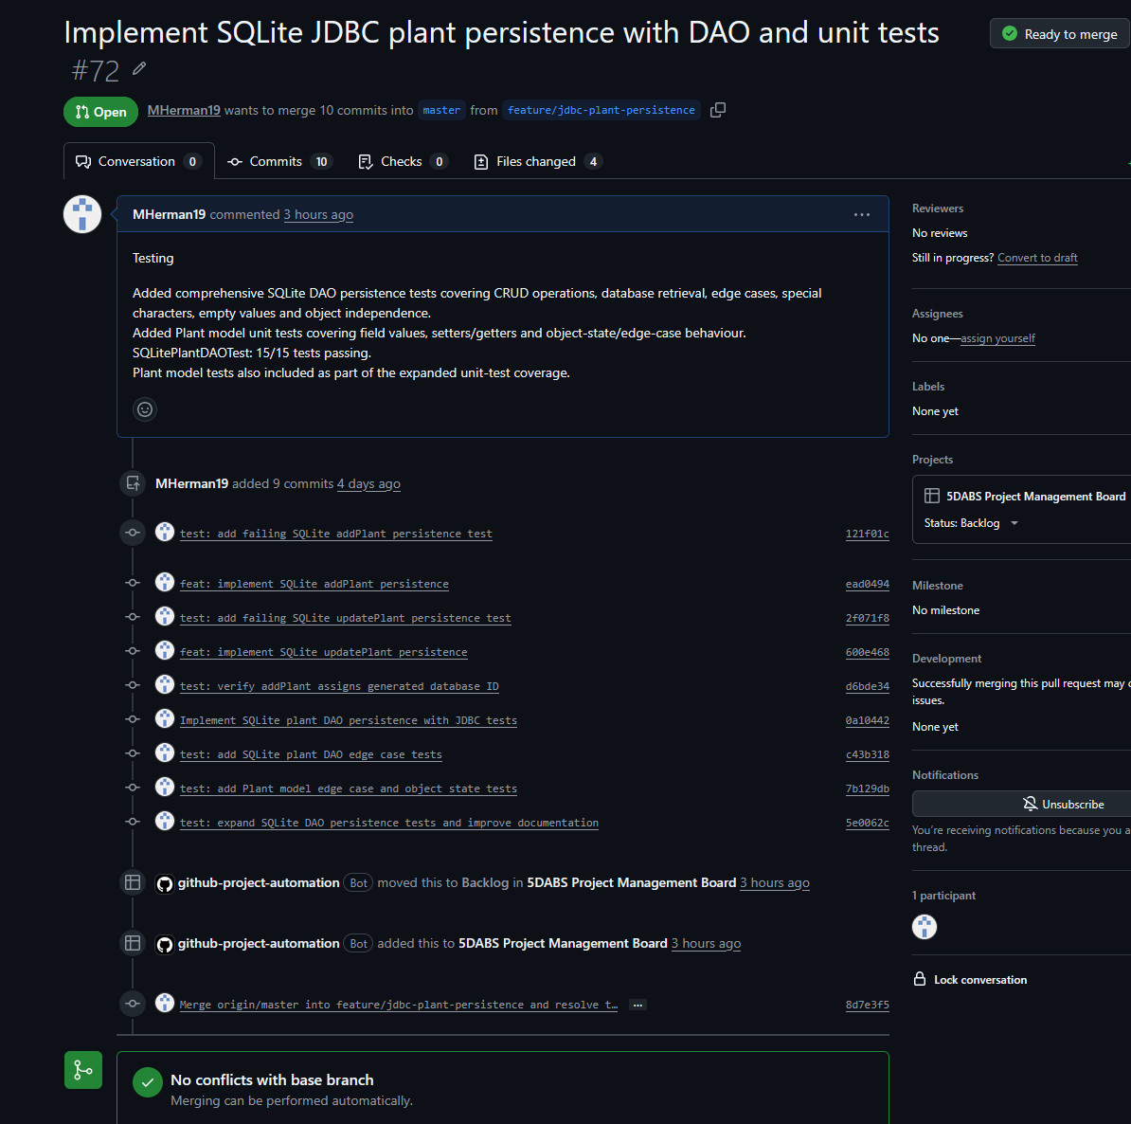

13. Selected Architecture and DAO Code Evidence
The architecture is reflected directly in the source code: SQLitePlantDAO implements the IPlantDAO contract, obtains connections through DatabaseConnection, and contains SQL persistence logic outside the JavaFX pages. The following excerpts are included to connect the architectural diagrams to the implemented classes.
Snippet 1 - DAO interface implementation structure
public class SQLitePlantDAO implements IPlantDAO {
@Override
public void addPlant(Plant plant) {
// JDBC INSERT implementation
}
@Override
public void updatePlant(Plant plant) {
// JDBC UPDATE implementation
}
@Override
public void deletePlant(Plant plant) {
// JDBC DELETE implementation
}
}
The method bodies are abbreviated here because this document is concerned with architectural responsibility. The complete SQL belongs in the persistence document and source repository.
Snippet 2 - Persistence responsibility remains inside SQLitePlantDAO
try (Connection connection = DatabaseConnection.getConnection();
PreparedStatement statement = connection.prepareStatement(sql)) {
// bind Plant values to SQL parameters
statement.executeUpdate();
} catch (SQLException e) {
throw new RuntimeException("Database operation failed", e);
}
This structure demonstrates separation of concerns: JavaFX pages do not need to create JDBC connections or execute SQL directly. The DAO is responsible for persistence, while DatabaseConnection centralises connection creation.
Snippet 3 - Testability through connection redirection
DatabaseConnection.setDatabaseUrl(
"jdbc:sqlite:" + testDatabasePath.toAbsolutePath()
);
Redirecting the database URL during testing is an architectural testability feature. It allows the same SQLitePlantDAO implementation to be exercised against a temporary database while preserving the production/team PlantsDB.db file.

14. Architecture Verification after Team Integration
During integration, the feature branch was updated with the latest master changes and test conflicts were resolved. The resulting local test run passed the SQLite persistence suite, and the pull request reported no conflicts with the base branch. This supports the current architecture documentation: the DAO/persistence implementation remained compatible with the evolved team package structure and Plant model after integration.

